**Leonardo Herrera Moreno (VG021498)**

**Assessment-2 (CSS)**

**Greystone College**

**Rolling Exercise HTML Part A**

Download index.html from this link -

https://github.com/asafamir10/css_rolling_exercise_1/blob/main/index.html

and add the following CSS classes:

1.) Add the following features to body selector.

a.) Arial font.

b.) Padding 10px.

2.) Add the following features to class header selector.

a.) Padding 30px.

b.) Text-align center.

c.) Background rgb(122, 89, 156).

3.) All the h2 tags will be with color rgb(122, 89, 156).

4.) All the h5 tags will be with color rgb(122, 165, 226).

5.) H1 in the header tag will have font-size 50px.

**style.css**

/*Rolling Exercise CSS Part A*/

body {

  font-family: arial;

  padding: 10px;

  background: #f1f1f1;

}

*.header* {

  padding: 30px;

  text-align: center;

  background: rgb(122, 89, 156);

  color: #fff;

}

h2 {

  color: rgb(122, 89, 156);

}

h5 {

  color: rgb(122, 165, 226);

}

*.header* h1 {

  font-size: 50px;

}

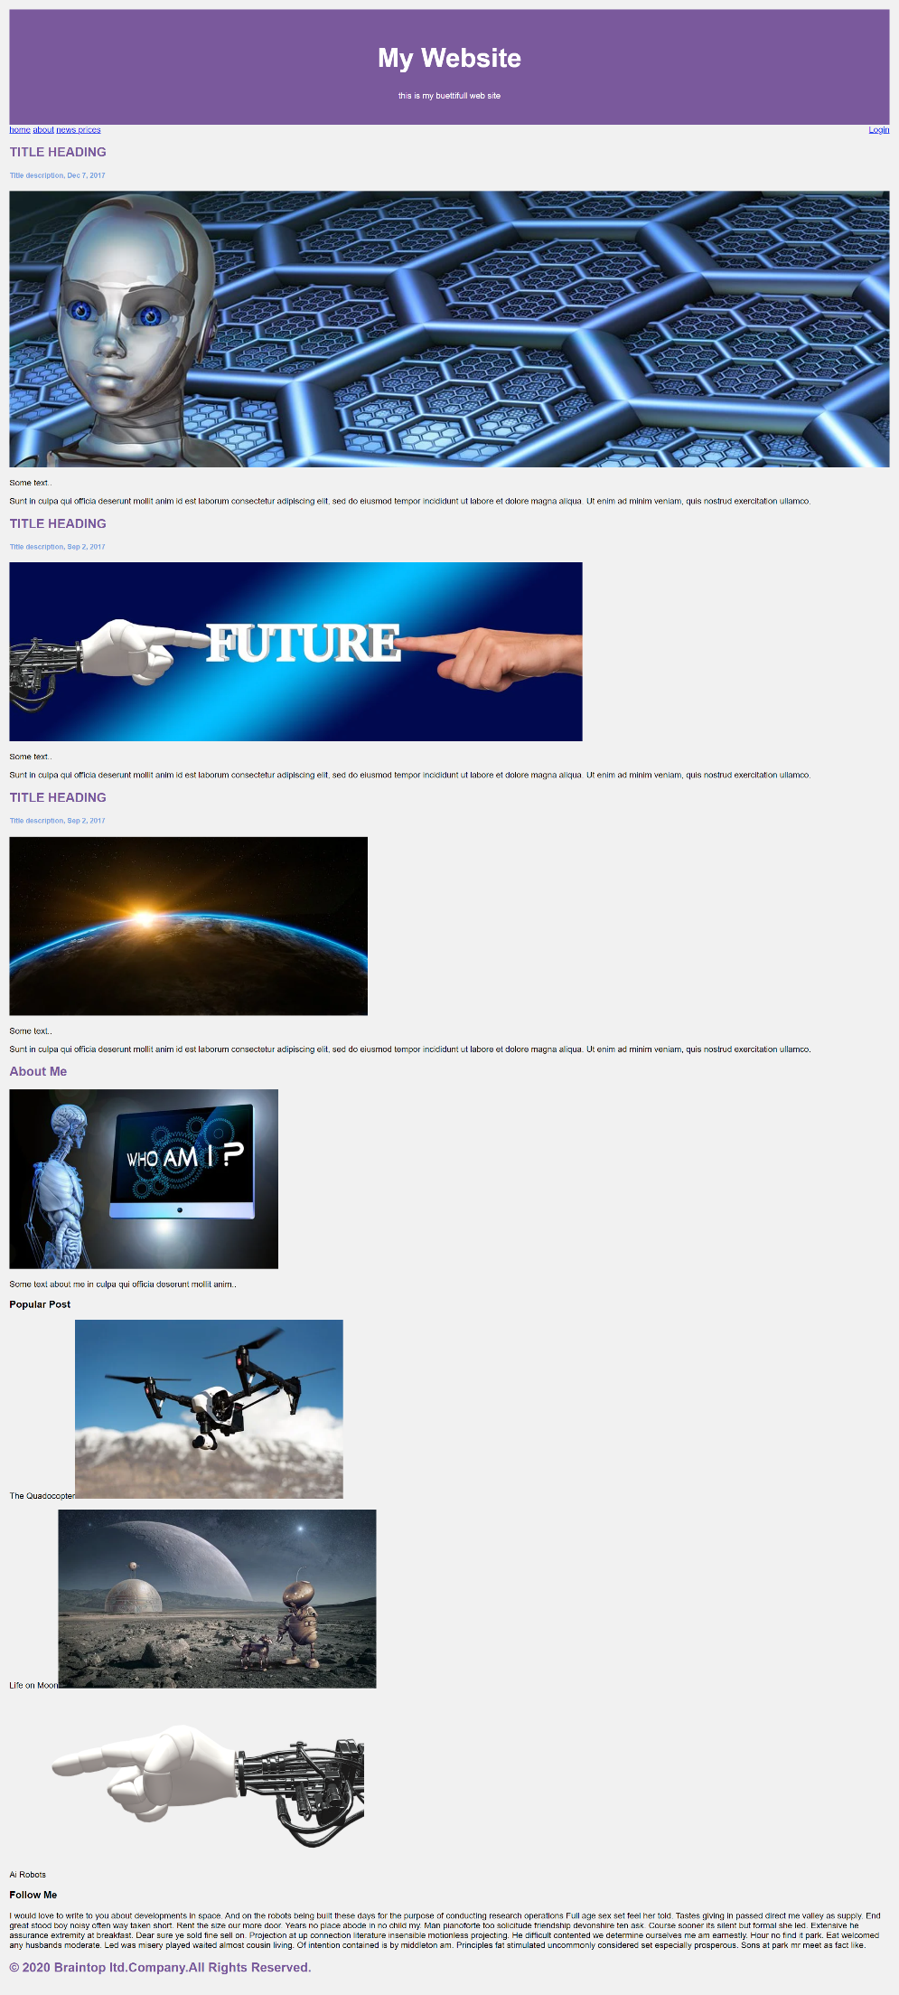

**Rolling Exercise HTML Part B**

Continuing with the previous exercise:

1.) Create a class frame with the following properties:

a.) 100% width.

b.) White background.

c.) Padding 5px.

d.) Margin top 20 px.

2.) All the images in the frame will be with the following properties:

a.) Background color #aaa.

b.) Padding 20px.

c.) Margin top 10px.

3.) Select all elements, and set their box-sizing to border-box(hint - *)

**style.css**

/*Rolling Exercise CSS Part B*/

* {

  box-sizing: border-box;

}

body {

  font-family: arial;

  padding: 10px;

  background: #f1f1f1;

}

*.header* {

  padding: 30px;

  text-align: center;

  background: rgb(122, 89, 156);

  color: #fff;

}

h2 {

  color: rgb(122, 89, 156);

}

h5 {

  color: rgb(122, 165, 226);

}

*.header* h1 {

  font-size: 50px;

}

*.frame* {

  width: 100%;

  background: white;

  padding: 5px;

  margin-top: 20px;

}

*.images* {

  background-color: #aaa;

  width: 100%;

  padding: 20px;

  margin-top: 10px;

}

*.images* img {

  width: 100%;

}

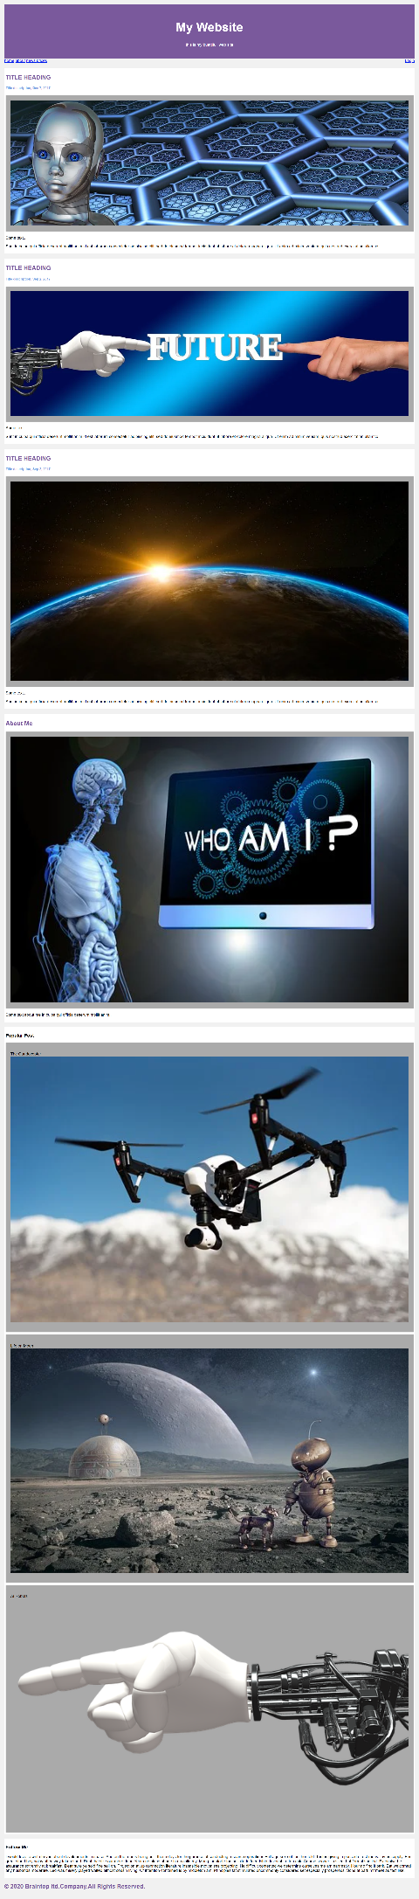

**Rolling Exercise HTML Part C**

Continuing from the previous rolling exercise:

1.) Divide the page into two parts

a.) Left part - 75% - class - leftcolumn

b.) Right part - 25% - class - rightcolumn with background color #f1f1f1, padding left 20px.

**style.css**

/*Rolling Exercise CSS Part A*/

* {

  box-sizing: border-box;

}

body {

  font-family: arial;

  padding: 10px;

  background: #f1f1f1;

}

*.header* {

  padding: 30px;

  text-align: center;

  background: rgb(122, 89, 156);

  color: #fff;

}

h2 {

  color: rgb(122, 89, 156);

}

h5 {

  color: rgb(122, 165, 226);

}

*.header* h1 {

  font-size: 50px;

}

/*Rolling Exercise CSS Part B*/

*.frame* {

  width: 100%;

  background: white;

  padding: 5px;

  margin-top: 20px;

}

*.images* {

  background-color: #aaa;

  width: 100%;

  padding: 20px;

  margin-top: 10px;

}

*.images* img {

  width: 100%;

}

/*Rolling Exercise CSS Part C*/

*.leftcolumn* {

  float: left;

  width: 75%;

}

*.rightcolumn* {

  float: left;

  width: 25%;

  background-color: #f1f1f1;

  padding-left: 20px;

}

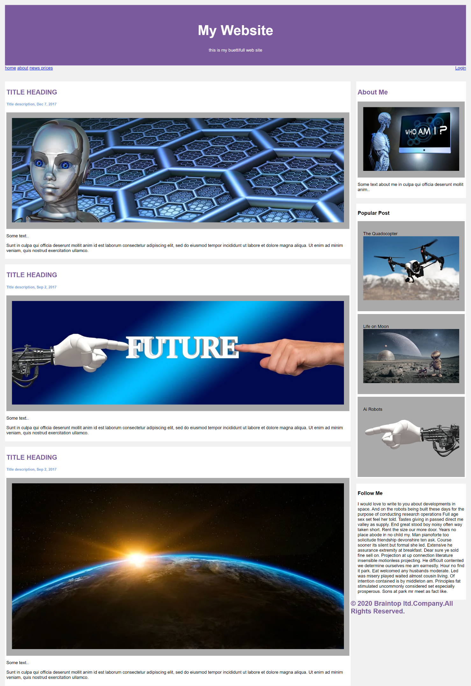

**Rolling Exercise HTML Part D**

Continuing from the previous rolling exercise:

1.) Create a cool navigation bar with

a.) Arial font

b.) Padding 10px

2.) Add the following features to header selector

a.) Padding 30px

b.) Text-align center

c.) Background rgb(122, 89, 156)

3.) All the h2 tags will be with color rgb(122, 89, 156)

4.) All the h5 tags will be with color rgb(122, 165, 226)

5.) h1 in the header tag will have font-size 50px

**style.css**

/*Rolling Exercise CSS Part A*/

* {

  box-sizing: border-box;

}

body {

  font-family: arial;

  padding: 10px;

  background: #f1f1f1;

}

*.header* {

  padding: 30px;

  text-align: center;

  background: rgb(122, 89, 156);

  color: #fff;

}

h2 {

  color: rgb(122, 89, 156);

}

h5 {

  color: rgb(122, 165, 226);

}

*.header* h1 {

  font-size: 50px;

}

/*Rolling Exercise CSS Part B*/

*.frame* {

  width: 100%;

  background: white;

  padding: 5px;

  margin-top: 20px;

}

*.images* {

  background-color: #aaa;

  width: 100%;

  padding: 20px;

  margin-top: 10px;

}

*.images* img {

  width: 100%;

}

/*Rolling Exercise CSS Part C*/

*.leftcolumn* {

  float: left;

  width: 75%;

}

*.rightcolumn* {

  float: left;

  width: 25%;

  background-color: #f1f1f1;

  padding-left: 20px;

}

/*Rolling Exercise CSS Part D*/

*.topnav* {

  overflow: hidden;

  background-color: rgb(255, 255, 255);

  font-family: Arial, sans-serif;

  padding: 10px;

}

*.topnav* a {

  float: left;

  color: rgb(122, 89, 156);

  text-align: center;

  padding: 14px 20px;

  text-decoration: none;

}

*.topnav* a*:hover* {

  background-color: #ddd;

  color: black;

}

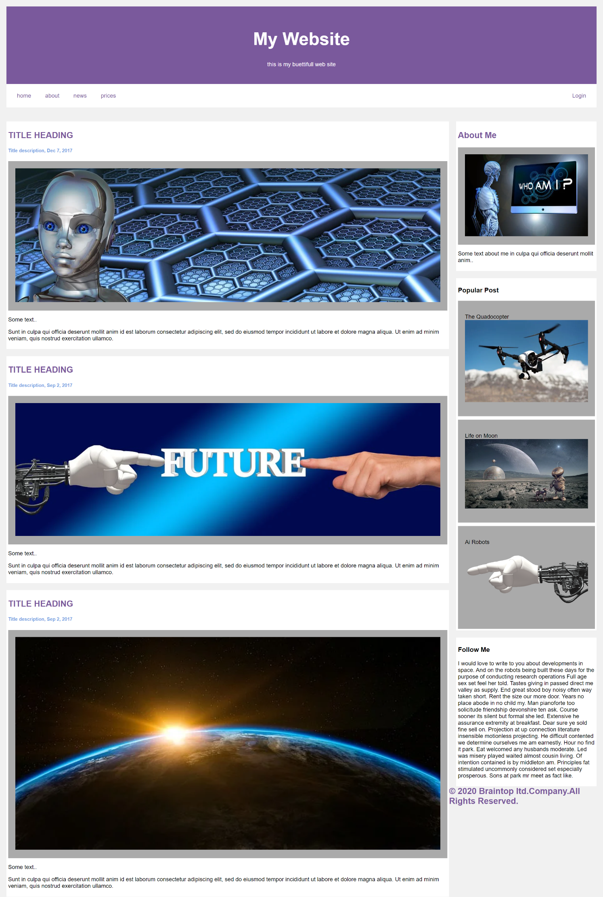

**Rolling Exercise HTML Part D**

Continuing from the previous rolling exercise:

1.) Create the CSS for the footer with:

display block

width 100%

float left

padding 20px

text-align center

background #ddd

**style.css**

/*Rolling Exercise CSS Part A*/

* {

  box-sizing: border-box;

}

body {

  font-family: arial;

  padding: 10px;

  background: #f1f1f1;

}

*.header* {

  padding: 30px;

  text-align: center;

  background: rgb(122, 89, 156);

  color: #fff;

}

h2 {

  color: rgb(122, 89, 156);

}

h5 {

  color: rgb(122, 165, 226);

}

*.header* h1 {

  font-size: 50px;

}

/*Rolling Exercise CSS Part B*/

*.frame* {

  width: 100%;

  background: white;

  padding: 5px;

  margin-top: 20px;

}

*.images* {

  background-color: #aaa;

  width: 100%;

  padding: 20px;

  margin-top: 10px;

}

*.images* img {

  width: 100%;

}

/*Rolling Exercise CSS Part C*/

*.leftcolumn* {

  float: left;

  width: 75%;

}

*.rightcolumn* {

  float: left;

  width: 25%;

  background-color: #f1f1f1;

  padding-left: 20px;

}

/*Rolling Exercise CSS Part D*/

*.topnav* {

  overflow: hidden;

  background-color: rgb(255, 255, 255);

  font-family: Arial, sans-serif;

  padding: 10px;

}

*.topnav* a {

  float: left;

  color: rgb(122, 89, 156);

  text-align: center;

  padding: 14px 20px;

  text-decoration: none;

}

*.topnav* a*:hover* {

  background-color: #ddd;

  color: black;

}

/*Rolling Exercise CSS Part E*/

*.footer* {

  display: block;

  width: 100%;

  float: left;

  padding: 20px;

  text-align: center;

  background: #ddd;

}

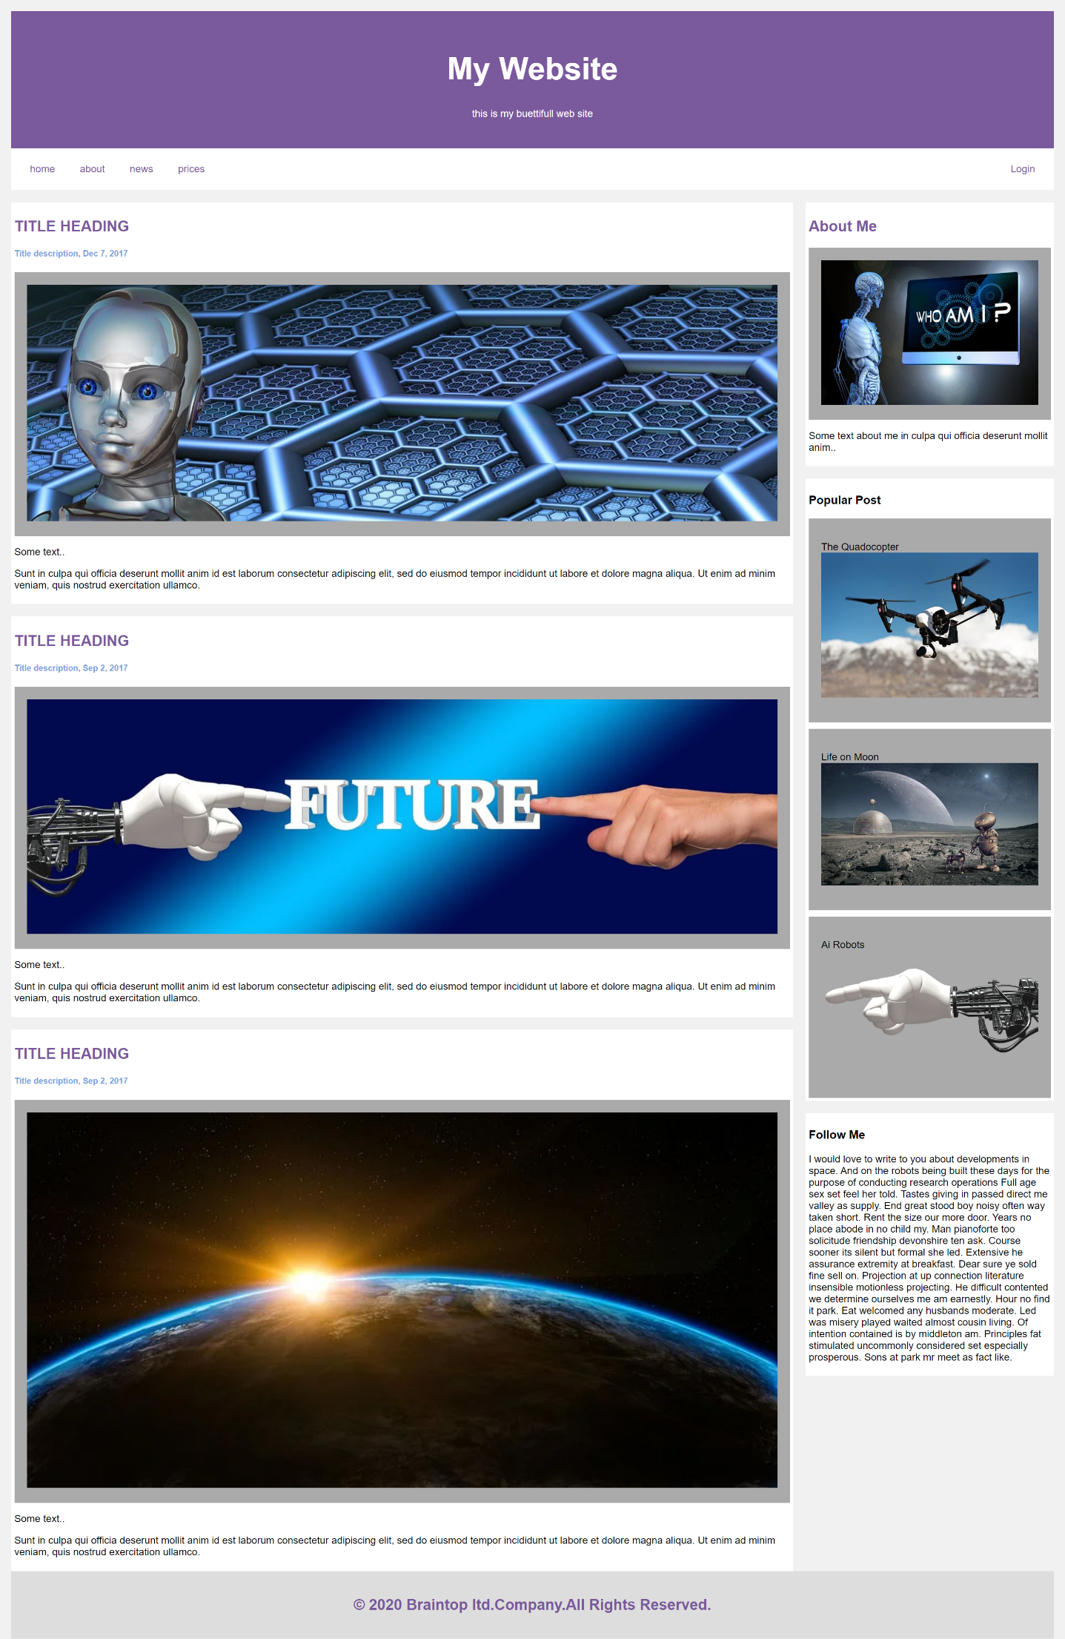

**Rolling Exercise Part-E Phase-1**

This final Exercise is comprised of 10 phases, do your best to replicate every single phase

Build next page.

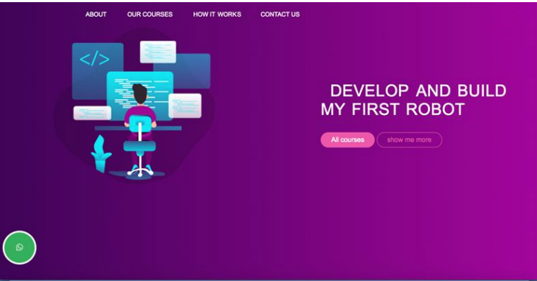

Index.html

<!DOCTYPE *html*>

<html *lang*="en">

<head>

  <meta *charset*="UTF-8" />

  <meta *name*="viewport" *content*="width=device-width, initial-scale=1.0" />

  <title>Your Website</title>

  <link *rel*="stylesheet" *href*="css/style-Phase-1-E.css" />

</head>

<!-- Rolling Exercise CSS Part E Phase 1-->

<body>

  <div>

    <ul>

      <li *class*="active"><a *href*="">ABOUT</a></li>

      <li><a *href*="">OUR COURSES</a></li>

      <li><a *href*="">HOW IT WORKS</a></li>

      <li><a *href*="">CONTACT US</a></li>

    </ul>

  </div>

  <div *class*="container">

    <img *id*="img1" *src*="images/study.png" *alt*="">

    <div *class*="text">

      <h1>

        DEVELOP AND BUILD<br />

        MY FIRST ROBOT

      </h1>

      <div>

        <button *class*="button">All courses</button>

        <button *class*="button">Show me more</button>

      </div>

    </div>

  </div>

  <img *src*="images/what-logo.png" *alt*="Sticky Image" *class*="sticky-img">

</body>

</html>

**style.css**

/* Rolling Exercise CSS Part E Phase 1 */

body {

  font-family: Arial;

  margin: 0;

  background: linear-gradient(to right, #7500a7, #ff78eb);

}

ul {

  list-style-type: none;

  padding: 25px;

  margin: 0;

  display: flex;

  justify-content: center;

}

li {

  margin: 0 10px;

}

a {

  display: block;

  padding: 0px 20px;

  font-size: 20px;

  color: rgb(255, 255, 255);

  text-decoration: none;

}

a*:hover* {

  color: rgb(255, 165, 185);

}

*#img1* {

  float: left;

  height: 500px;

  width: auto;

  margin-right: 200px;

  margin-left: 200px;

}

*.text* {

  padding: 100px 0;

}

h1 {

  font-size: 45px;

  color: white;

  text-indent: 50px;

}

*.button* {

  padding: 8px 16px;

  background-color: rgba(0, 0, 0, 0);

  color: rgb(255, 165, 185);

  text-decoration: none;

  border: solid;

  border-radius: 20px;

  cursor: pointer;

  margin: 0 5px;

}

*.button:hover* {

  background-color: #ff72a1;

  color: white;

  border-color: transparent;

}

*.sticky-img* {

  position: fixed;

  left: 0;

  bottom: 0;

  z-index: 999;

  width: 100px;

  height: auto;

  padding: 100px;

}

*.sticky-img:hover* {

  transform: scale(1.1);

  cursor: pointer;

}

@media only screen and (max-width: 480px) {

  ul {

    flex-direction: column;

    padding: 30px;

    margin: 0 0 0 100px;

  }

  a {

    border-bottom: 1px solid #ccc;

    width: 55%;

  }

*#img1* {

  display: none;

}

*.text* {

    padding: 20px;

    text-align: center;

  }

h1 {

    font-size: 24px;

    text-indent: 0;

  }

*.button* {

    padding: 6px 12px;

    margin: 5px;

}

*.sticky-img* {

  width: 80px;

  height: auto;

  padding: 100px;

  margin-bottom: 30%;

}

}

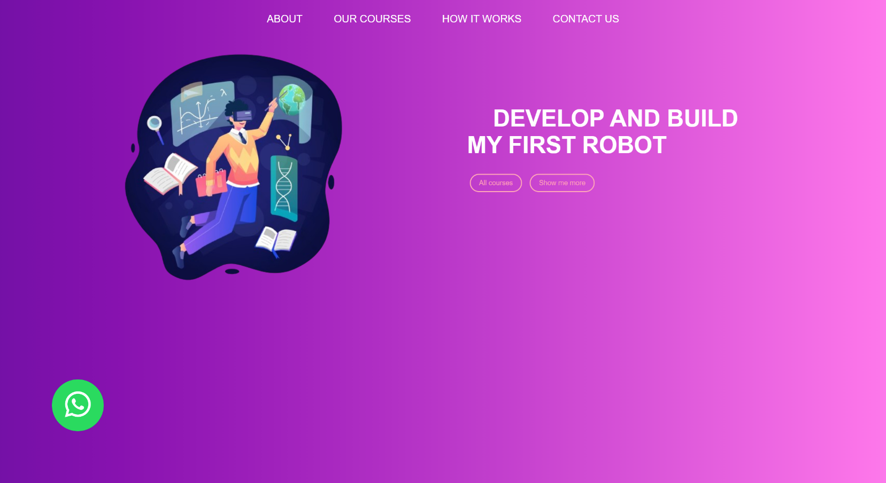

**Rolling Exercise Part-E Phase-2**

Add the next section to the previous page.

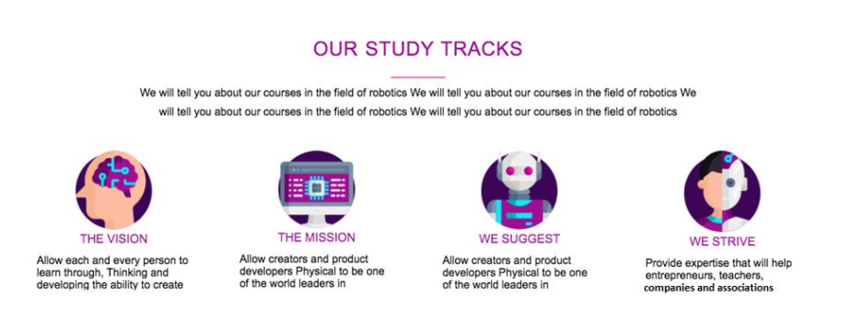

Index.html

<!DOCTYPE *html*>

<html *lang*="en">

<head>

  <meta *charset*="UTF-8" />

  <meta *name*="viewport" *content*="width=device-width, initial-scale=1.0" />

  <title>Your Website</title>

  <link *rel*="stylesheet" *href*="css/style-Phase-2-E.css" />

</head>

<body>

<!-- Rolling Exercise CSS Part E Phase 1-->

 <!-- section-1 -->

<section *class*="section1">

  <div>

    <ul *class*="lista1">

      <li *class*="navegado1"><a *class*="secciones1" *href*="">ABOUT</a></li>

      <li *class*="navegado1"><a *class*="secciones1" *href*="">OUR COURSES</a></li>

      <li *class*="navegado1"><a *class*="secciones1" *href*="">CONTACT US</a></li>

      <li *class*="navegado1"><a *class*="secciones1" *href*="">HOW IT WORKS</a></li>

    </ul>

  </div>

  <div *class*="container1">

    <img *id*="img1" *src*="images/study.png" *alt*="">

    <div *class*="text1">

      <h1 *class*="titulo1">

        DEVELOP AND BUILD<br/>

        MY FIRST ROBOT

      </h1>

      <div>

        <button *class*="button1">All courses</button>

        <button *class*="button1">Show me more</button>

      </div>

    </div>

  </div>

</section>

<!-- Rolling Exercise CSS Part E Phase 2-->

<!-- section-2 -->

<section *class*="section2">

  <div *class*="top2">

    <h1 *class*="titulo2">OUR STUDY TRACKS</h1>

    <p>Lorem ipsum dolor, sit amet consectetur adipisicing elit. Obcaecati dignissimos provident dolorum nam nesciunt oluta iste dolore est deleniti<br> sit dolores fugiat alias, perspiciatis, ea soluta iste dolore accusantium necessitatibus odio maiores ullam.</p>

  </div>

  <div *class*="flex-container2">

    <div *class*="flex-item2">

      <img *src*="images/rounded-1.png" *alt*="Image" />

      <h1 *class*="sub-tituli2">THE VISION</h1>

      <p>Allow each and every persone to<br> learn through, Thinking and<br> developing the ability to create</p>

    </div>

    <div *class*="flex-item2">

      <img *src*="images/rounded-2.png" *alt*="Image" />

      <h1 *class*="sub-tituli2">THE MISSION</h1>

      <p>Allow creators and product <br> developers Physical to be one<br> of the world leaders in</p>

    </div>

    <div *class*="flex-item2">

      <img *src*="images/rounded-3.png" *alt*="Image" />

      <h1 *class*="sub-tituli2">WE SUGGEST</h1>

      <p><p>Allow creators and product <br> developers Physical to be one<br> of the world leaders in</p>

    </div>

    <div *class*="flex-item2">

      <img *src*="images/rounded-4.png" *alt*="Image" />

      <h1 *class*="sub-tituli2">WE STRIVE</h1>

      <p>Provede expertise that will help<br> entrepreneurs, teacher,<br> companies and associations</p>

    </div>

  </div>

</section>

<img *src*="images/what-logo.png" *alt*="Sticky Image" *class*="sticky-img">

</body>

</html>

Style.css

body {

  font-family: Arial;

}

/* Rolling Exercise CSS Part E Phase 2 */

/* section-1 */

*.section1* {

  background: linear-gradient(to right, #7500a7, #ff78eb);

  width: auto;

  height: 100vh;

  padding: 100px;

}

*.lista1* {

  list-style-type: none;

  padding: 25px;

  margin: 0;

  display: flex;

  justify-content: center;

}

*.navegador1* {

  margin: 0 10px;

}

*.secciones1* {

  display: block;

  padding: 0px 20px;

  font-size: 20px;

  color: rgb(255, 255, 255);

  text-decoration: none;

}

*.secciones1:hover* {

  color: rgb(255, 165, 185);

}

*#img1* {

  float: left;

  height: 500px;

  width: auto;

  margin-right: 100px;

  margin-left: 90px;

}

*.text* {

  padding: 100px 0;

}

*.titulo1* {

  font-size: 45px;

  color: white;

  text-indent: 50px;

}

*.button1* {

  padding: 8px 16px;

  background-color: rgba(0, 0, 0, 0);

  color: rgb(255, 165, 185);

  text-decoration: none;

  border: solid;

  border-radius: 20px;

  cursor: pointer;

  margin: 0 5px;

}

*.button1:hover* {

  background-color: #ff72a1;

  color: white;

  border-color: transparent;

}

/* button sticky */

*.sticky-img* {

  position: fixed;

  left: 0;

  bottom: 0;

  z-index: 999;

  width: 100px;

  height: auto;

  padding: 100px;

}

*.sticky-img:hover* {

  transform: scale(1.1);

  cursor: pointer;

}

/* section-2 */

*.top2* {

  text-align: center;

  margin-bottom: 10px;

}

*.titulo2*{

  border-bottom: 2px solid;

  display: inline-block;

  padding-bottom: 5px;

  color: #7500a7;

}

*.sub-tituli2* {

  color: #7500a7;

}

*.flex-container2* {

  display: flex;

  flex-wrap: wrap;

  justify-content: space-around;

  align-items: flex-start;

  min-height: 100vh;

  margin-top: 10px;

}

*.flex-item2* {

  text-align: center;

  flex: 1 0 auto;

  margin: 5px;

  box-sizing: border-box;

}

*.flex-item2* img {

  max-width: 50%;

}

*.flex-item2* h1 {

  margin: 0;

}

*.flex-item2* p {

  margin: 10px 0;

}

@media only screen and (max-width: 480px) {

  /* section-1 */

*.lista1* {

    flex-direction: column;

  }

*.secciones1* {

    border-bottom: 1px solid #ccc;

  }

*#img1* {

  display: none;

}

*.text1* {

    padding: 20px;

    text-align: center;

  }

*.titulo1* {

    font-size: 24px;

    text-indent: 0;

  }

  /* button sticky */

*.button* {

    padding: 6px 12px;

    margin: 5px;

}

*.sticky-img* {

  width: 80px;

  height: auto;

  padding: 100px;

  margin-bottom: 30%;

}

/* section-2 */

*.flex-item2* {

    flex-basis: 100%;

  }

}

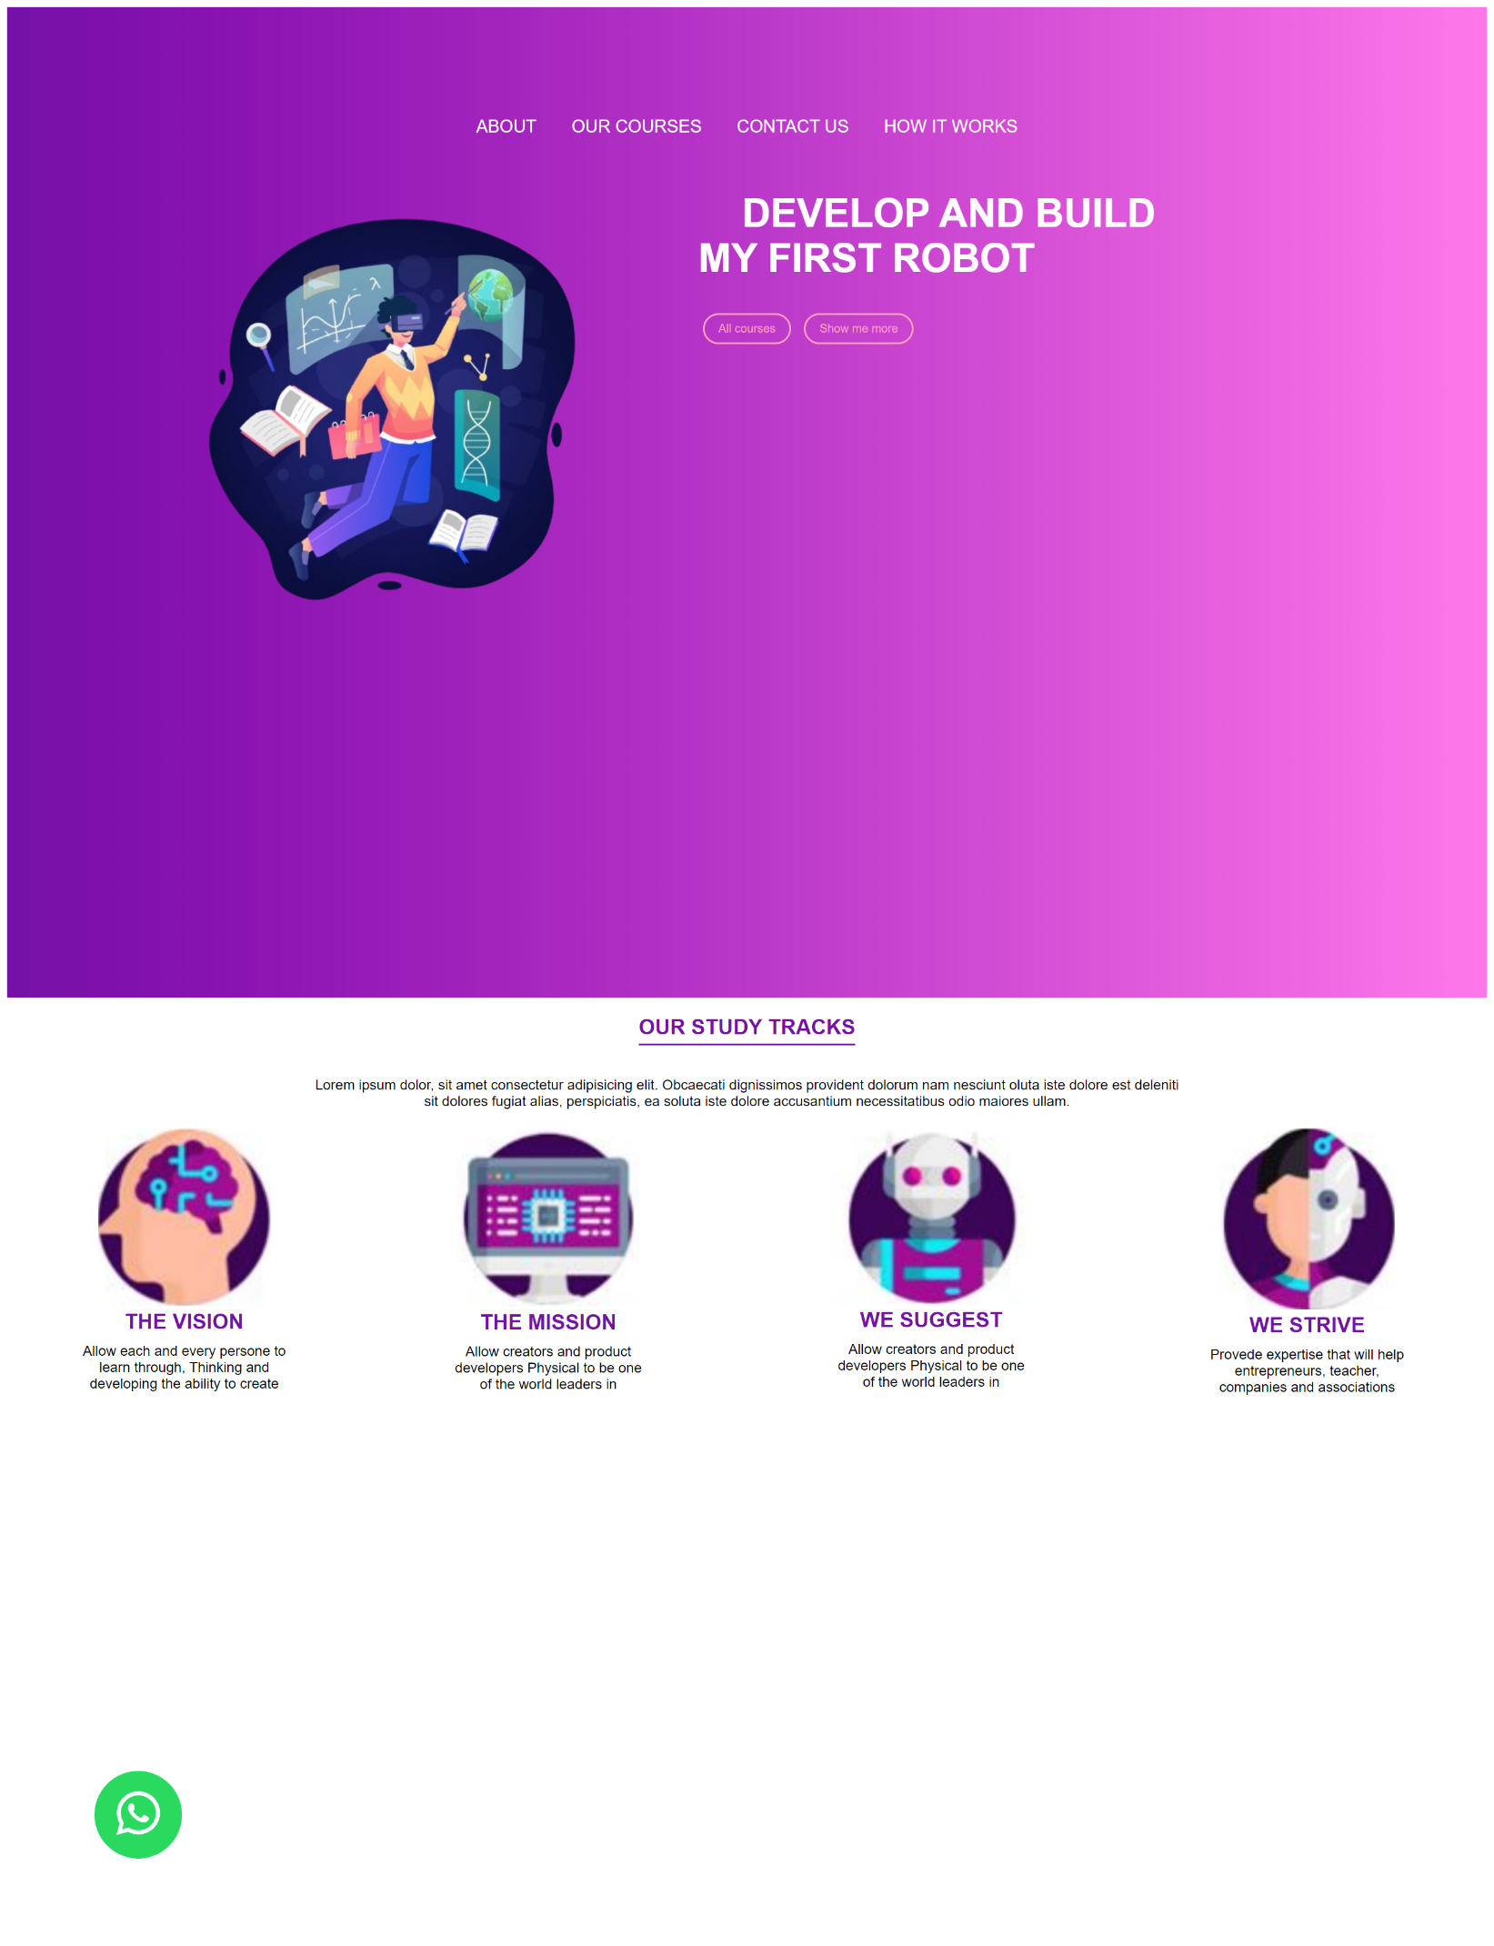

**Rolling Exercise Part-E Phase-3**

Add the next section to the previous page.

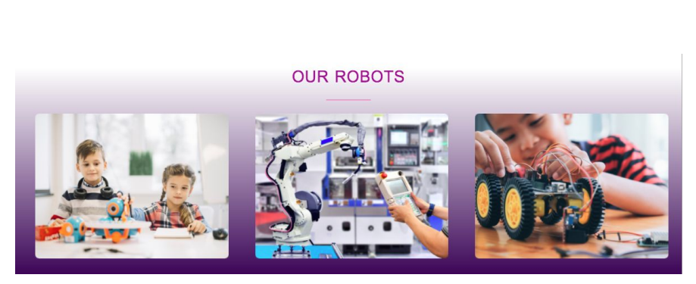

Index.html

<!DOCTYPE *html*>

<html *lang*="en">

<head>

  <meta *charset*="UTF-8" />

  <meta *name*="viewport" *content*="width=device-width, initial-scale=1.0" />

  <title>Your Website</title>

  <link *rel*="stylesheet" *href*="css/style-Phase-3-E.css" />

</head>

<body>

<!-- Rolling Exercise CSS Part E Phase 1-->

 <!-- section-1 -->

<section *class*="section1">

  <div>

    <ul *class*="lista1">

      <li *class*="navegado1"><a *class*="secciones1" *href*="">ABOUT</a></li>

      <li *class*="navegado1"><a *class*="secciones1" *href*="">OUR COURSES</a></li>

      <li *class*="navegado1"><a *class*="secciones1" *href*="">CONTACT US</a></li>

      <li *class*="navegado1"><a *class*="secciones1" *href*="">HOW IT WORKS</a></li>

    </ul>

  </div>

  <div *class*="container1">

    <img *id*="img1" *src*="images/study.png" *alt*="">

    <div *class*="text1">

      <h1 *class*="titulo1">

        DEVELOP AND BUILD<br/>

        MY FIRST ROBOT

      </h1>

      <div>

        <button *class*="button1">All courses</button>

        <button *class*="button1">Show me more</button>

      </div>

    </div>

  </div>

</section>

<!-- Rolling Exercise CSS Part E Phase 2-->

<!-- section-2 -->

<section *class*="section2">

  <div *class*="top2">

    <h1 *class*="titulo2">OUR STUDY TRACKS</h1>

    <p>Lorem ipsum dolor, sit amet consectetur adipisicing elit. Obcaecati dignissimos provident dolorum nam nesciunt oluta iste dolore est deleniti<br> sit dolores fugiat alias, perspiciatis, ea soluta iste dolore accusantium necessitatibus odio maiores ullam.</p>

  </div>

  <div *class*="flex-container2">

    <div *class*="flex-item2">

      <img *src*="images/rounded-1.png" *alt*="Image" />

      <h1 *class*="sub-tituli2">THE VISION</h1>

      <p>Allow each and every persone to<br> learn through, Thinking and<br> developing the ability to create</p>

    </div>

    <div *class*="flex-item2">

      <img *src*="images/rounded-2.png" *alt*="Image" />

      <h1 *class*="sub-tituli2">THE MISSION</h1>

      <p>Allow creators and product <br> developers Physical to be one<br> of the world leaders in</p>

    </div>

    <div *class*="flex-item2">

      <img *src*="images/rounded-3.png" *alt*="Image" />

      <h1 *class*="sub-tituli2">WE SUGGEST</h1>

      <p><p>Allow creators and product <br> developers Physical to be one<br> of the world leaders in</p>

    </div>

    <div *class*="flex-item2">

      <img *src*="images/rounded-4.png" *alt*="Image" />

      <h1 *class*="sub-tituli2">WE STRIVE</h1>

      <p>Provede expertise that will help<br> entrepreneurs, teacher,<br> companies and associations</p>

    </div>

  </div>

</section>

<!-- Rolling Exercise CSS Part E Phase 3-->

<!-- section-3 -->

<section *class*="section3">

  <div *class*="top3">

    <h1 *class*="titulo3">OUR ROBOTS</h1>

  </div>

  <div *class*="flex-container3">

    <div *class*="flex-item3">

      <img *src*="images/nino-1.png" *alt*="Image" />

    </div>

    <div *class*="flex-item3">

      <img *src*="images/nino-2.png" *alt*="kis" />

    </div>

    <div *class*="flex-item3">

      <img *src*="images/nino-3.png" *alt*="Image" />

    </div>

  </div>

</section>

<img *src*="images/what-logo.png" *alt*="Sticky Image" *class*="sticky-img">

</body>

</html>

Style.css

body {

  font-family: Arial;

}

/* Rolling Exercise CSS Part E Phase 3 */

/* section-1 */

*.section1* {

  background: linear-gradient(to right, #7500a7, #ff78eb);

  width: auto;

  height: 100vh;

  padding: 100px;

}

*.lista1* {

  list-style-type: none;

  padding: 25px;

  margin: 0;

  display: flex;

  justify-content: center;

}

*.navegador1* {

  margin: 0 10px;

}

*.secciones1* {

  display: block;

  padding: 0px 20px;

  font-size: 20px;

  color: rgb(255, 255, 255);

  text-decoration: none;

}

*.secciones1:hover* {

  color: rgb(255, 165, 185);

}

*#img1* {

  float: left;

  height: 500px;

  width: auto;

  margin-right: 100px;

  margin-left: 90px;

}

*.text* {

  padding: 100px 0;

}

*.titulo1* {

  font-size: 45px;

  color: white;

  text-indent: 50px;

}

*.button1* {

  padding: 8px 16px;

  background-color: rgba(0, 0, 0, 0);

  color: rgb(255, 165, 185);

  text-decoration: none;

  border: solid;

  border-radius: 20px;

  cursor: pointer;

  margin: 0 5px;

}

*.button1:hover* {

  background-color: #ff72a1;

  color: white;

  border-color: transparent;

}

/* button sticky */

*.sticky-img* {

  position: fixed;

  left: 0;

  bottom: 0;

  z-index: 999;

  width: 100px;

  height: auto;

  padding: 100px;

}

*.sticky-img:hover* {

  transform: scale(1.1);

  cursor: pointer;

}

/* section-2 */

*.top2* {

  text-align: center;

  margin-bottom: 10px;

}

*.titulo2*{

  border-bottom: 2px solid;

  display: inline-block;

  padding-bottom: 5px;

  color: #7500a7;

}

*.sub-tituli2* {

  color: #7500a7;

}

*.flex-container2* {

  display: flex;

  flex-wrap: wrap;

  justify-content: space-around;

  align-items: flex-start;

  min-height: 100vh;

  margin-top: 10px;

}

*.flex-item2* {

  text-align: center;

  flex: 1 0 auto;

  margin: 5px;

  box-sizing: border-box;

}

*.flex-item2* img {

  max-width: 50%;

}

*.flex-item2* h1 {

  margin: 0;

}

*.flex-item2* p {

  margin: 10px 0;

}

/* section-3 */

*.section3* {

  font-family: Arial;

  background: linear-gradient(to top, #7500a7, #ffffff);

}

*.top3* {

  text-align: center;

  margin-bottom: 10px;

  color: rgb(107, 23, 130);

}

*.titulo3* {

  border-bottom: 2px solid;

  display: inline-block;

  padding-bottom: 5px;

}

*.flex-container3* {

  display: flex;

  flex-wrap: wrap;

  justify-content: space-around;

  align-items: flex-start;

  min-height: 100vh;

  margin-top: 10px;

}

*.flex-item3* {

  text-align: center;

  flex: 1 0 10%;

  margin:10px;

  box-sizing: border-box;

}

*.flex-item3* img {

  border-radius: 30px;

  max-width: 90%;

}

@media only screen and (max-width: 480px) {

  /* section-1 */

*.lista1* {

    flex-direction: column;

  }

*.secciones1* {

    border-bottom: 1px solid #ccc;

  }

*#img1* {

  display: none;

}

*.text1* {

    padding: 20px;

    text-align: center;

  }

*.titulo1* {

    font-size: 24px;

    text-indent: 0;

  }

  /* button sticky */

*.button* {

    padding: 6px 12px;

    margin: 5px;

}

*.sticky-img* {

  width: 80px;

  height: auto;

  padding: 100px;

  margin-bottom: 30%;

}

/* section-2 */

*.flex-item2* {

    flex-basis: 100%;

  }

/* section-3 */

*.flex-item3* {

  flex-basis: 100%;

}

}

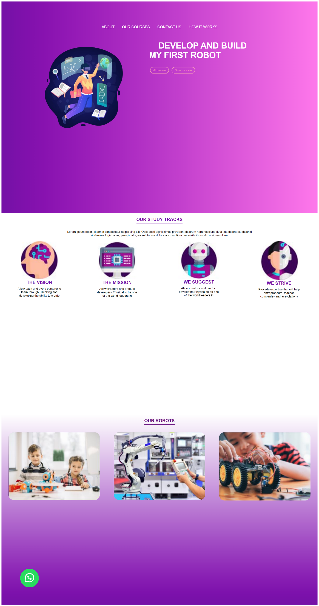

**Rolling Exercise Part-E Phase-4**

Add the next section to the previous page.

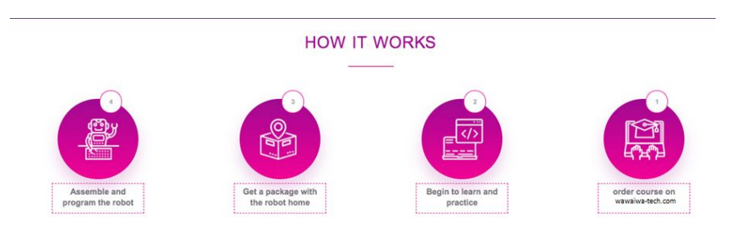

Index.html

<!DOCTYPE *html*>

<html *lang*="en">

<head>

  <meta *charset*="UTF-8" />

  <meta *name*="viewport" *content*="width=device-width, initial-scale=1.0" />

  <title>Your Website</title>

  <link *rel*="stylesheet" *href*="css/style-Phase-4-E.css" />

</head>

<body>

<!-- Rolling Exercise CSS Part E Phase 1-->

 <!-- section-1 -->

<section *class*="section1">

  <div>

    <ul *class*="lista1">

      <li *class*="navegado1"><a *class*="secciones1" *href*="">ABOUT</a></li>

      <li *class*="navegado1"><a *class*="secciones1" *href*="">OUR COURSES</a></li>

      <li *class*="navegado1"><a *class*="secciones1" *href*="">CONTACT US</a></li>

      <li *class*="navegado1"><a *class*="secciones1" *href*="">HOW IT WORKS</a></li>

    </ul>

  </div>

  <div *class*="container1">

    <img *id*="img1" *src*="images/study.png" *alt*="">

    <div *class*="text1">

      <h1 *class*="titulo1">

        DEVELOP AND BUILD<br/>

        MY FIRST ROBOT

      </h1>

      <div>

        <button *class*="button1">All courses</button>

        <button *class*="button1">Show me more</button>

      </div>

    </div>

  </div>

</section>

<!-- Rolling Exercise CSS Part E Phase 2-->

<!-- section-2 -->

<section *class*="section2">

  <div *class*="top2">

    <h1 *class*="titulo2">OUR STUDY TRACKS</h1>

    <p>Lorem ipsum dolor, sit amet consectetur adipisicing elit. Obcaecati dignissimos provident dolorum nam nesciunt oluta iste dolore est deleniti<br> sit dolores fugiat alias, perspiciatis, ea soluta iste dolore accusantium necessitatibus odio maiores ullam.</p>

  </div>

  <div *class*="flex-container2">

    <div *class*="flex-item2">

      <img *src*="images/rounded-1.png" *alt*="Image" />

      <h1 *class*="sub-tituli2">THE VISION</h1>

      <p>Allow each and every persone to<br> learn through, Thinking and<br> developing the ability to create</p>

    </div>

    <div *class*="flex-item2">

      <img *src*="images/rounded-2.png" *alt*="Image" />

      <h1 *class*="sub-tituli2">THE MISSION</h1>

      <p>Allow creators and product <br> developers Physical to be one<br> of the world leaders in</p>

    </div>

    <div *class*="flex-item2">

      <img *src*="images/rounded-3.png" *alt*="Image" />

      <h1 *class*="sub-tituli2">WE SUGGEST</h1>

      <p><p>Allow creators and product <br> developers Physical to be one<br> of the world leaders in</p>

    </div>

    <div *class*="flex-item2">

      <img *src*="images/rounded-4.png" *alt*="Image" />

      <h1 *class*="sub-tituli2">WE STRIVE</h1>

      <p>Provede expertise that will help<br> entrepreneurs, teacher,<br> companies and associations</p>

    </div>

  </div>

</section>

<!-- Rolling Exercise CSS Part E Phase 3-->

<!-- section-3 -->

<section *class*="section3">

  <div *class*="top3">

    <h1 *class*="titulo3">OUR ROBOTS</h1>

  </div>

  <div *class*="flex-container3">

    <div *class*="flex-item3">

      <img *src*="images/nino-1.png" *alt*="Image" />

    </div>

    <div *class*="flex-item3">

      <img *src*="images/nino-2.png" *alt*="kis" />

    </div>

    <div *class*="flex-item3">

      <img *src*="images/nino-3.png" *alt*="Image" />

    </div>

  </div>

</section>

<!-- Rolling Exercise CSS Part E Phase 4-->

<!-- section-4 -->

<section *class*="section4">

  <div *class*="container4">

    <h1 *class*="titulo4">How It Works</h1>

  </div>

  <div *class*="flex-container-4">

    <div *class*="flex-item-4">

      <img *src*="images/rounded-5.png" *alt*="Your Image" *class*="circle-img">

      <div>

        <p>Assemble and<br> program the robot

      </div>

    </div>

    <div *class*="flex-item-4">

      <img *src*="images/rounded-6.png" *alt*="Your Image" *class*="circle-img">

      <div>

        <p>Get a package with<br> the robot home

      </div>

    </div>

    <div *class*="flex-item-4">

      <img *src*="images/rounded-7.png" *alt*="Your Image" *class*="circle-img">

      <div>

        <p>Begin to learn<br> and practice

      </div>

    </div>

    <div *class*="flex-item-4">

      <img *src*="images/rounded-8.png" *alt*="Your Image" *class*="circle-img">

      <div>

        <p>Order Course on<br> Wawalwa Tech</p>

      </div>

    </div>

  </div>

</section>

<img *src*="images/what-logo.png" *alt*="Sticky Image" *class*="sticky-img">

</body>

</html>

**style.css**

body {

  font-family: Arial;

}

/* Rolling Exercise CSS Part E Phase 4 */

/* section-1 */

*.section1* {

  background: linear-gradient(to right, #7500a7, #ff78eb);

  width: auto;

  height: 100vh;

  padding: 100px;

}

*.lista1* {

  list-style-type: none;

  padding: 25px;

  margin: 0;

  display: flex;

  justify-content: center;

}

*.navegador1* {

  margin: 0 10px;

}

*.secciones1* {

  display: block;

  padding: 0px 20px;

  font-size: 20px;

  color: rgb(255, 255, 255);

  text-decoration: none;

}

*.secciones1:hover* {

  color: rgb(255, 165, 185);

}

*#img1* {

  float: left;

  height: 500px;

  width: auto;

  margin-right: 100px;

  margin-left: 90px;

}

*.text* {

  padding: 100px 0;

}

*.titulo1* {

  font-size: 45px;

  color: white;

  text-indent: 50px;

}

*.button1* {

  padding: 8px 16px;

  background-color: rgba(0, 0, 0, 0);

  color: rgb(255, 165, 185);

  text-decoration: none;

  border: solid;

  border-radius: 20px;

  cursor: pointer;

  margin: 0 5px;

}

*.button1:hover* {

  background-color: #ff72a1;

  color: white;

  border-color: transparent;

}

/* button sticky */

*.sticky-img* {

  position: fixed;

  left: 0;

  bottom: 0;

  z-index: 999;

  width: 100px;

  height: auto;

  padding: 100px;

}

*.sticky-img:hover* {

  transform: scale(1.1);

  cursor: pointer;

}

/* section-2 */

*.top2* {

  text-align: center;

  margin-bottom: 10px;

}

*.titulo2*{

  border-bottom: 2px solid;

  display: inline-block;

  padding-bottom: 5px;

  color: #7500a7;

}

*.sub-tituli2* {

  color: #7500a7;

}

*.flex-container2* {

  display: flex;

  flex-wrap: wrap;

  justify-content: space-around;

  align-items: flex-start;

  min-height: 100vh;

  margin-top: 10px;

}

*.flex-item2* {

  text-align: center;

  flex: 1 0 auto;

  margin: 5px;

  box-sizing: border-box;

}

*.flex-item2* img {

  max-width: 50%;

}

*.flex-item2* h1 {

  margin: 0;

}

*.flex-item2* p {

  margin: 10px 0;

}

/* section-3 */

*.section3* {

  font-family: Arial;

  background: linear-gradient(to top, #7500a7, #ffffff);

}

*.top3* {

  text-align: center;

  margin-bottom: 10px;

  color: rgb(107, 23, 130);

}

*.titulo3* {

  border-bottom: 2px solid;

  display: inline-block;

  padding-bottom: 5px;

}

*.flex-container3* {

  display: flex;

  flex-wrap: wrap;

  justify-content: space-around;

  align-items: flex-start;

  min-height: 100vh;

  margin-top: 10px;

}

*.flex-item3* {

  text-align: center;

  flex: 1 0 10%;

  margin:10px;

  box-sizing: border-box;

}

*.flex-item3* img {

  border-radius: 30px;

  max-width: 90%;

}

/* section-4 */

*.container4* {

  text-align: center;

  margin-bottom: 10px;

}

*.titulo4*{

  border-bottom: 2px solid;

  display: inline-block;

  padding-bottom: 5px;

  color: rgb(114, 22, 108);

}

*.flex-container-4* {

  display: flex;

  flex-wrap: wrap;

  justify-content: space-around;

  align-items: flex-start;

  min-height: 100vh;

  margin-top: 10px;

}

*.flex-item-4* {

  text-align: center;

  flex: 1 0 auto;

  margin: 100px;

  box-sizing: border-box;

}

*.flex-item-4* img {

  width: 150px;

  height: 150px;

}

*.flex-item-4* p {

  margin: 5px 0;

  border: 2px dotted rgb(255, 165, 185);;

  padding: 5px;

}

@media only screen and (max-width: 480px) {

  /* section-1 */

*.lista1* {

    flex-direction: column;

  }

*.secciones1* {

    border-bottom: 1px solid #ccc;

  }

*#img1* {

  display: none;

}

*.text1* {

    padding: 20px;

    text-align: center;

  }

*.titulo1* {

    font-size: 24px;

    text-indent: 0;

  }

  /* button sticky */

*.button* {

    padding: 6px 12px;

    margin: 5px;

}

*.sticky-img* {

  width: 80px;

  height: auto;

  padding: 100px;

  margin-bottom: 30%;

  margin-left: -10%;

}

/* section-2 */

*.flex-item2* {

    flex-basis: 100%;

  }

/* section-3 */

*.flex-item3* {

  flex-basis: 100%;

}

/* section-4 */

*.flex-item-4* {

  flex-basis: 60%;

  margin: 5px 0;

  padding: 5px;

}

}

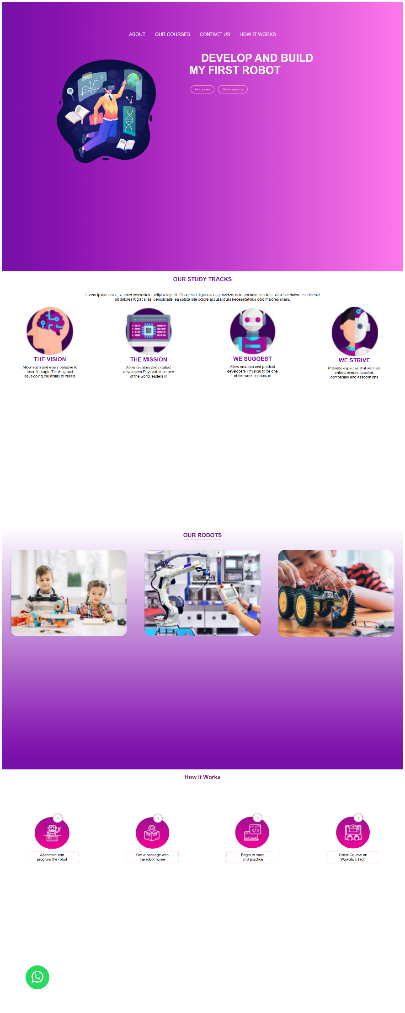

**Rolling Exercise Part-E Phase-5**

Add the next section to the previous page.

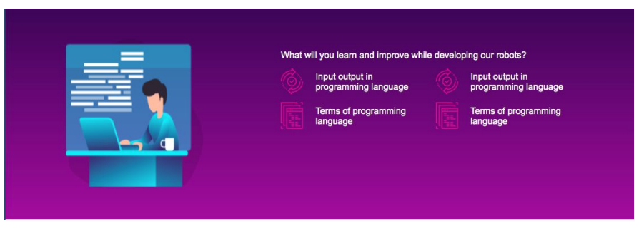

Index.html

<!DOCTYPE *html*>

<html *lang*="en">

<head>

  <meta *charset*="UTF-8" />

  <meta *name*="viewport" *content*="width=device-width, initial-scale=1.0" />

  <title>Your Website</title>

  <link *rel*="stylesheet" *href*="css/style-Phase-5-E.css" />

</head>

<body>

<!-- Rolling Exercise CSS Part E Phase 1-->

 <!-- section-1 -->

<section *class*="section1">

  <div>

    <ul *class*="lista1">

      <li *class*="navegado1"><a *class*="secciones1" *href*="">ABOUT</a></li>

      <li *class*="navegado1"><a *class*="secciones1" *href*="">OUR COURSES</a></li>

      <li *class*="navegado1"><a *class*="secciones1" *href*="">CONTACT US</a></li>

      <li *class*="navegado1"><a *class*="secciones1" *href*="">HOW IT WORKS</a></li>

    </ul>

  </div>

  <div *class*="container1">

    <img *id*="img1" *src*="images/study.png" *alt*="">

    <div *class*="text1">

      <h1 *class*="titulo1">

        DEVELOP AND BUILD<br/>

        MY FIRST ROBOT

      </h1>

      <div>

        <button *class*="button1">All courses</button>

        <button *class*="button1">Show me more</button>

      </div>

    </div>

  </div>

</section>

<!-- Rolling Exercise CSS Part E Phase 2-->

<!-- section-2 -->

<section *class*="section2">

  <div *class*="top2">

    <h1 *class*="titulo2">OUR STUDY TRACKS</h1>

    <p>Lorem ipsum dolor, sit amet consectetur adipisicing elit. Obcaecati dignissimos provident dolorum nam nesciunt oluta iste dolore est deleniti<br> sit dolores fugiat alias, perspiciatis, ea soluta iste dolore accusantium necessitatibus odio maiores ullam.</p>

  </div>

  <div *class*="flex-container2">

    <div *class*="flex-item2">

      <img *src*="images/rounded-1.png" *alt*="Image" />

      <h1 *class*="sub-tituli2">THE VISION</h1>

      <p>Allow each and every persone to<br> learn through, Thinking and<br> developing the ability to create</p>

    </div>

    <div *class*="flex-item2">

      <img *src*="images/rounded-2.png" *alt*="Image" />

      <h1 *class*="sub-tituli2">THE MISSION</h1>

      <p>Allow creators and product <br> developers Physical to be one<br> of the world leaders in</p>

    </div>

    <div *class*="flex-item2">

      <img *src*="images/rounded-3.png" *alt*="Image" />

      <h1 *class*="sub-tituli2">WE SUGGEST</h1>

      <p><p>Allow creators and product <br> developers Physical to be one<br> of the world leaders in</p>

    </div>

    <div *class*="flex-item2">

      <img *src*="images/rounded-4.png" *alt*="Image" />

      <h1 *class*="sub-tituli2">WE STRIVE</h1>

      <p>Provede expertise that will help<br> entrepreneurs, teacher,<br> companies and associations</p>

    </div>

  </div>

</section>

<!-- Rolling Exercise CSS Part E Phase 3-->

<!-- section-3 -->

<section *class*="section3">

  <div *class*="top3">

    <h1 *class*="titulo3">OUR ROBOTS</h1>

  </div>

  <div *class*="flex-container3">

    <div *class*="flex-item3">

      <img *src*="images/nino-1.png" *alt*="Image" />

    </div>

    <div *class*="flex-item3">

      <img *src*="images/nino-2.png" *alt*="kis" />

    </div>

    <div *class*="flex-item3">

      <img *src*="images/nino-3.png" *alt*="Image" />

    </div>

  </div>

</section>

<!-- Rolling Exercise CSS Part E Phase 4-->

<!-- section-4 -->

<section *class*="section4">

  <div *class*="container4">

    <h1 *class*="titulo4">How It Works</h1>

  </div>

  <div *class*="flex-container-4">

    <div *class*="flex-item-4">

      <img *src*="images/rounded-5.png" *alt*="Your Image" *class*="circle-img">

      <div>

        <p>Assemble and<br> program the robot

      </div>

    </div>

    <div *class*="flex-item-4">

      <img *src*="images/rounded-6.png" *alt*="Your Image" *class*="circle-img">

      <div>

        <p>Get a package with<br> the robot home

      </div>

    </div>

    <div *class*="flex-item-4">

      <img *src*="images/rounded-7.png" *alt*="Your Image" *class*="circle-img">

      <div>

        <p>Begin to learn<br> and practice

      </div>

    </div>

    <div *class*="flex-item-4">

      <img *src*="images/rounded-8.png" *alt*="Your Image" *class*="circle-img">

      <div>

        <p>Order Course on<br> Wawalwa Tech</p>

      </div>

    </div>

  </div>

</section>

<!-- Rolling Exercise CSS Part E Phase 5-->

<!-- section-5 -->

<section *class*="section5">

<div *class*="container5">

  <img *src*="images/desk.png" *alt*="Desk Image" *class*="left-image">

  <div *class*="text-content5">

    <p>What will you learn and improve while developing our robots?</p>

    <div *class*="paragraph-container">

      <p>

        <img *src*="images/bulb.png" *alt*="Bulb Image" *class*="small-image">

        Input/output in programming languages

      </p>

      <p>

        <img *src*="images/claud.png" *alt*="Claud Image" *class*="small-image">

        Input/output in programming languages

      </p>

      <p>

        <img *src*="images/bulb.png" *alt*="Bulb Image" *class*="small-image">

        Terms of programming languages

      </p>

      <p>

        <img *src*="images/claud.png" *alt*="Claud Image" *class*="small-image">

        Terms of programming languages

      </p>

    </div>

  </div>

</div>

</section>

<img *src*="images/what-logo.png" *alt*="Sticky Image" *class*="sticky-img">

</body>

</html>

</body>

</html>

**style.css**

body {

  font-family: Arial;

}

/* Rolling Exercise CSS Part E Phase 5 */

/* section-1 */

*.section1* {

  background: linear-gradient(to right, #7500a7, #ff78eb);

  width: auto;

  height: 100vh;

  padding: 100px;

}

*.lista1* {

  list-style-type: none;

  padding: 25px;

  margin: 0;

  display: flex;

  justify-content: center;

}

*.navegador1* {

  margin: 0 10px;

}

*.secciones1* {

  display: block;

  padding: 0px 20px;

  font-size: 20px;

  color: rgb(255, 255, 255);

  text-decoration: none;

}

*.secciones1:hover* {

  color: rgb(255, 165, 185);

}

*#img1* {

  float: left;

  height: 500px;

  width: auto;

  margin-right: 100px;

  margin-left: 90px;

}

*.text* {

  padding: 100px 0;

}

*.titulo1* {

  font-size: 45px;

  color: white;

  text-indent: 50px;

}

*.button1* {

  padding: 8px 16px;

  background-color: rgba(0, 0, 0, 0);

  color: rgb(255, 165, 185);

  text-decoration: none;

  border: solid;

  border-radius: 20px;

  cursor: pointer;

  margin: 0 5px;

}

*.button1:hover* {

  background-color: #ff72a1;

  color: white;

  border-color: transparent;

}

/* button sticky */

*.sticky-img* {

  position: fixed;

  left: 0;

  bottom: 0;

  z-index: 999;

  width: 100px;

  height: auto;

  padding: 100px;

}

*.sticky-img:hover* {

  transform: scale(1.1);

  cursor: pointer;

}

/* section-2 */

*.top2* {

  text-align: center;

  margin-bottom: 10px;

}

*.titulo2*{

  border-bottom: 2px solid;

  display: inline-block;

  padding-bottom: 5px;

  color: #7500a7;

}

*.sub-tituli2* {

  color: #7500a7;

}

*.flex-container2* {

  display: flex;

  flex-wrap: wrap;

  justify-content: space-around;

  align-items: flex-start;

  min-height: 100vh;

  margin-top: 10px;

}

*.flex-item2* {

  text-align: center;

  flex: 1 0 auto;

  margin: 5px;

  box-sizing: border-box;

}

*.flex-item2* img {

  max-width: 50%;

}

*.flex-item2* h1 {

  margin: 0;

}

*.flex-item2* p {

  margin: 10px 0;

}

/* section-3 */

*.section3* {

  font-family: Arial;

  background: linear-gradient(to top, #7500a7, #ffffff);

}

*.top3* {

  text-align: center;

  margin-bottom: 10px;

  color: rgb(107, 23, 130);

}

*.titulo3* {

  border-bottom: 2px solid;

  display: inline-block;

  padding-bottom: 5px;

}

*.flex-container3* {

  display: flex;

  flex-wrap: wrap;

  justify-content: space-around;

  align-items: flex-start;

  min-height: 100vh;

  margin-top: 10px;

}

*.flex-item3* {

  text-align: center;

  flex: 1 0 10%;

  margin:10px;

  box-sizing: border-box;

}

*.flex-item3* img {

  border-radius: 30px;

  max-width: 90%;

}

/* section-4 */

*.container4* {

  text-align: center;

  margin-bottom: 10px;

}

*.titulo4*{

  border-bottom: 2px solid;

  display: inline-block;

  padding-bottom: 5px;

  color: rgb(114, 22, 108);

}

*.flex-container-4* {

  display: flex;

  flex-wrap: wrap;

  justify-content: space-around;

  align-items: flex-start;

  min-height: 100vh;

  margin-top: 10px;

}

*.flex-item-4* {

  text-align: center;

  flex: 1 0 auto;

  margin: 100px;

  box-sizing: border-box;

}

*.flex-item-4* img {

  width: 150px;

  height: 150px;

}

*.flex-item-4* p {

  margin: 5px 0;

  border: 2px dotted rgb(255, 165, 185);;

  padding: 5px;

}

/* section-5 */

*.section5* {

  font-family: Arial;

  margin: 0;

  min-height: 100vh;

  background: linear-gradient(to bottom, #7500a7, #ff78eb);

  color: white;

}

*.container5* {

  display: flex;

  align-items: center;

  justify-content: center;

}

*.left-image* {

  width: 30%;

  object-fit: cover;

  margin-top: 50px;

  margin-right: 50px;

}

*.paragraph-container* {

  column-count: 2;

  column-gap: 20px;

}

*.paragraph-container* p {

  margin-top: 3px;

}

*.small-image* {

  margin-right: 10px;

  width: 50px;

  border-radius: 50%;

  vertical-align: middle;

}

/* section-6 */

@media only screen and (max-width: 480px) {

  /* section-1 */

*.lista1* {

    flex-direction: column;

  }

*.secciones1* {

    border-bottom: 1px solid #ccc;

  }

*#img1* {

  display: none;

}

*.text1* {

    padding: 20px;

    text-align: center;

  }

*.titulo1* {

    font-size: 24px;

    text-indent: 0;

  }

  /* button sticky */

*.button* {

    padding: 6px 12px;

    margin: 5px;

}

*.sticky-img* {

  width: 80px;

  height: auto;

  padding: 100px;

  margin-bottom: 30%;

  margin-left: -10%;

}

/* section-2 */

*.flex-item2* {

    flex-basis: 100%;

  }

/* section-3 */

*.flex-item3* {

  flex-basis: 100%;

}

/* section-4 */

*.flex-item-4* {

  flex-basis: 60%;

  margin: 5px 0;

  padding: 5px;

}

/* section-5 */

}

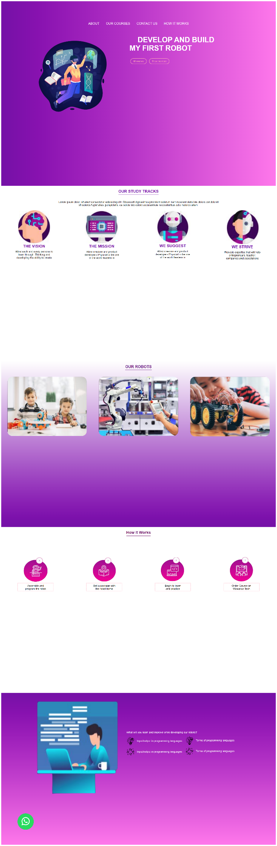

**Rolling Exercise Part-E Phase-6**

Add the next section to the previous page.

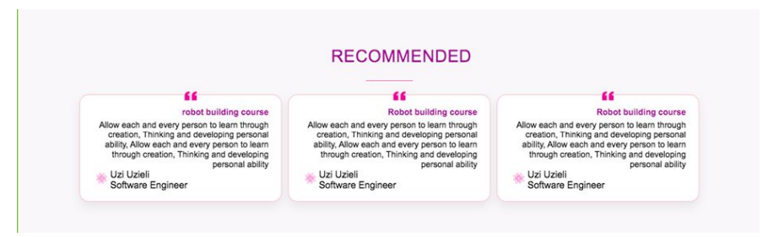

Index.html

<!DOCTYPE *html*>

<html *lang*="en">

<head>

  <meta *charset*="UTF-8" />

  <meta *name*="viewport" *content*="width=device-width, initial-scale=1.0" />

  <title>Your Website</title>

  <link *rel*="stylesheet" *href*="css/style-Phase-6-E.css" />

</head>

<body>

<!-- Rolling Exercise CSS Part E Phase 1-->

 <!-- section-1 -->

<section *class*="section1">

  <div>

    <ul *class*="lista1">

      <li *class*="navegado1"><a *class*="secciones1" *href*="">ABOUT</a></li>

      <li *class*="navegado1"><a *class*="secciones1" *href*="">OUR COURSES</a></li>

      <li *class*="navegado1"><a *class*="secciones1" *href*="">CONTACT US</a></li>

      <li *class*="navegado1"><a *class*="secciones1" *href*="">HOW IT WORKS</a></li>

    </ul>

  </div>

  <div *class*="container1">

    <img *id*="img1" *src*="images/study.png" *alt*="">

    <div *class*="text1">

      <h1 *class*="titulo1">

        DEVELOP AND BUILD<br/>

        MY FIRST ROBOT

      </h1>

      <div>

        <button *class*="button1">All courses</button>

        <button *class*="button1">Show me more</button>

      </div>

    </div>

  </div>

</section>

<!-- Rolling Exercise CSS Part E Phase 2-->

<!-- section-2 -->

<section *class*="section2">

  <div *class*="top2">

    <h1 *class*="titulo2">OUR STUDY TRACKS</h1>

    <p>Lorem ipsum dolor, sit amet consectetur adipisicing elit. Obcaecati dignissimos provident dolorum nam nesciunt oluta iste dolore est deleniti<br> sit dolores fugiat alias, perspiciatis, ea soluta iste dolore accusantium necessitatibus odio maiores ullam.</p>

  </div>

  <div *class*="flex-container2">

    <div *class*="flex-item2">

      <img *src*="images/rounded-1.png" *alt*="Image" />

      <h1 *class*="sub-tituli2">THE VISION</h1>

      <p>Allow each and every persone to<br> learn through, Thinking and<br> developing the ability to create</p>

    </div>

    <div *class*="flex-item2">

      <img *src*="images/rounded-2.png" *alt*="Image" />

      <h1 *class*="sub-tituli2">THE MISSION</h1>

      <p>Allow creators and product <br> developers Physical to be one<br> of the world leaders in</p>

    </div>

    <div *class*="flex-item2">

      <img *src*="images/rounded-3.png" *alt*="Image" />

      <h1 *class*="sub-tituli2">WE SUGGEST</h1>

      <p><p>Allow creators and product <br> developers Physical to be one<br> of the world leaders in</p>

    </div>

    <div *class*="flex-item2">

      <img *src*="images/rounded-4.png" *alt*="Image" />

      <h1 *class*="sub-tituli2">WE STRIVE</h1>

      <p>Provede expertise that will help<br> entrepreneurs, teacher,<br> companies and associations</p>

    </div>

  </div>

</section>

<!-- Rolling Exercise CSS Part E Phase 3-->

<!-- section-3 -->

<section *class*="section3">

  <div *class*="top3">

    <h1 *class*="titulo3">OUR ROBOTS</h1>

  </div>

  <div *class*="flex-container3">

    <div *class*="flex-item3">

      <img *src*="images/nino-1.png" *alt*="Image" />

    </div>

    <div *class*="flex-item3">

      <img *src*="images/nino-2.png" *alt*="kis" />

    </div>

    <div *class*="flex-item3">

      <img *src*="images/nino-3.png" *alt*="Image" />

    </div>

  </div>

</section>

<!-- Rolling Exercise CSS Part E Phase 4-->

<!-- section-4 -->

<section *class*="section4">

  <div *class*="container4">

    <h1 *class*="titulo4">How It Works</h1>

  </div>

  <div *class*="flex-container-4">

    <div *class*="flex-item-4">

      <img *src*="images/rounded-5.png" *alt*="Your Image" *class*="circle-img">

      <div>

        <p>Assemble and<br> program the robot

      </div>

    </div>

    <div *class*="flex-item-4">

      <img *src*="images/rounded-6.png" *alt*="Your Image" *class*="circle-img">

      <div>

        <p>Get a package with<br> the robot home

      </div>

    </div>

    <div *class*="flex-item-4">

      <img *src*="images/rounded-7.png" *alt*="Your Image" *class*="circle-img">

      <div>

        <p>Begin to learn<br> and practice

      </div>

    </div>

    <div *class*="flex-item-4">

      <img *src*="images/rounded-8.png" *alt*="Your Image" *class*="circle-img">

      <div>

        <p>Order Course on<br> Wawalwa Tech</p>

      </div>

    </div>

  </div>

</section>

<!-- Rolling Exercise CSS Part E Phase 5-->

<!-- section-5 -->

<section *class*="section5">

<div *class*="container5">

  <img *src*="images/desk.png" *alt*="Desk Image" *class*="left-image">

  <div *class*="text-content5">

    <p>What will you learn and improve while developing our robots?</p>

    <div *class*="paragraph-container">

      <p>

        <img *src*="images/bulb.png" *alt*="Bulb Image" *class*="small-image">

        Input/output in programming languages

      </p>

      <p>

        <img *src*="images/claud.png" *alt*="Claud Image" *class*="small-image">

        Input/output in programming languages

      </p>

      <p>

        <img *src*="images/bulb.png" *alt*="Bulb Image" *class*="small-image">

        Terms of programming languages

      </p>

      <p>

        <img *src*="images/claud.png" *alt*="Claud Image" *class*="small-image">

        Terms of programming languages

      </p>

    </div>

  </div>

</div>

</section>

<!-- Rolling Exercise CSS Part E Phase 6-->

<!-- section-6 -->

<section *class*="section6">

<div *class*="top-6">

  <h1 *id*="title-6">Recommended</h1>

  </div>

  <div *class*="box-container6">

    <div *class*="box6">

      <div *class*="box-text6">

        <p>Robot Building Course<br>Allow each and every person to learn through creation, Thinking and developing personal ability.</p>

      </div>

      <div *class*="box-footer6">

        <img *src*="images/bulb.png">

        <p>Uzi Uzieli<br>Software Engineer</p>

      </div>

    </div>

    <div *class*="box6">

      <div *class*="box-text6">

        <p>Robot Building Course<br>Allow each and every person to learn through creation, Thinking and developing personal ability.</p>

      </div>

      <div *class*="box-footer6">

        <img *src*="images/bulb.png">

        <p>Uzi Uzieli<br>Software Engineer</p>

      </div>

    </div>

    <div *class*="box6">

      <div *class*="box-text6">

        <p>Robot Building Course<br>Allow each and every person to learn through creation, Thinking and developing personal ability.</p>

      </div>

      <div *class*="box-footer6">

        <img *src*="images/bulb.png">

        <p>Uzi Uzieli<br>Software Engineer</p>

      </div>

    </div>

  </div>

</section>

<img *src*="images/what-logo.png" *alt*="Sticky Image" *class*="sticky-img">

</body>

</html>

**style.css**

body {

  font-family: Arial;

}

/* Rolling Exercise CSS Part E Phase 6 */

/* section-1 */

*.section1* {

  background: linear-gradient(to right, #7500a7, #ff78eb);

  width: auto;

  height: 100vh;

  padding: 100px;

}

*.lista1* {

  list-style-type: none;

  padding: 25px;

  margin: 0;

  display: flex;

  justify-content: center;

}

*.navegador1* {

  margin: 0 10px;

}

*.secciones1* {

  display: block;

  padding: 0px 20px;

  font-size: 20px;

  color: rgb(255, 255, 255);

  text-decoration: none;

}

*.secciones1:hover* {

  color: rgb(255, 165, 185);

}

*#img1* {

  float: left;

  height: 500px;

  width: auto;

  margin-right: 100px;

  margin-left: 90px;

}

*.text* {

  padding: 100px 0;

}

*.titulo1* {

  font-size: 45px;

  color: white;

  text-indent: 50px;

}

*.button1* {

  padding: 8px 16px;

  background-color: rgba(0, 0, 0, 0);

  color: rgb(255, 165, 185);

  text-decoration: none;

  border: solid;

  border-radius: 20px;

  cursor: pointer;

  margin: 0 5px;

}

*.button1:hover* {

  background-color: #ff72a1;

  color: white;

  border-color: transparent;

}

/* button sticky */

*.sticky-img* {

  position: fixed;

  left: 0;

  bottom: 0;

  z-index: 999;

  width: 100px;

  height: auto;

  padding: 100px;

}

*.sticky-img:hover* {

  transform: scale(1.1);

  cursor: pointer;

}

/* section-2 */

*.top2* {

  text-align: center;

  margin-bottom: 10px;

}

*.titulo2*{

  border-bottom: 2px solid;

  display: inline-block;

  padding-bottom: 5px;

  color: #7500a7;

}

*.sub-tituli2* {

  color: #7500a7;

}

*.flex-container2* {

  display: flex;

  flex-wrap: wrap;

  justify-content: space-around;

  align-items: flex-start;

  min-height: 100vh;

  margin-top: 10px;

}

*.flex-item2* {

  text-align: center;

  flex: 1 0 auto;

  margin: 5px;

  box-sizing: border-box;

}

*.flex-item2* img {

  max-width: 50%;

}

*.flex-item2* h1 {

  margin: 0;

}

*.flex-item2* p {

  margin: 10px 0;

}

/* section-3 */

*.section3* {

  font-family: Arial;

  background: linear-gradient(to top, #7500a7, #ffffff);

}

*.top3* {

  text-align: center;

  margin-bottom: 10px;

  color: rgb(107, 23, 130);

}

*.titulo3* {

  border-bottom: 2px solid;

  display: inline-block;

  padding-bottom: 5px;

}

*.flex-container3* {

  display: flex;

  flex-wrap: wrap;

  justify-content: space-around;

  align-items: flex-start;

  min-height: 100vh;

  margin-top: 10px;

}

*.flex-item3* {

  text-align: center;

  flex: 1 0 10%;

  margin:10px;

  box-sizing: border-box;

}

*.flex-item3* img {

  border-radius: 30px;

  max-width: 90%;

}

/* section-4 */

*.container4* {

  text-align: center;

  margin-bottom: 10px;

}

*.titulo4*{

  border-bottom: 2px solid;

  display: inline-block;

  padding-bottom: 5px;

  color: rgb(114, 22, 108);

}

*.flex-container-4* {

  display: flex;

  flex-wrap: wrap;

  justify-content: space-around;

  align-items: flex-start;

  min-height: 100vh;

  margin-top: 10px;

}

*.flex-item-4* {

  text-align: center;

  flex: 1 0 auto;

  margin: 100px;

  box-sizing: border-box;

}

*.flex-item-4* img {

  width: 150px;

  height: 150px;

}

*.flex-item-4* p {

  margin: 5px 0;

  border: 2px dotted rgb(255, 165, 185);;

  padding: 5px;

}

/* section-5 */

*.section5* {

  font-family: Arial;

  margin: 0;

  min-height: 100vh;

  background: linear-gradient(to bottom, #7500a7, #ff78eb);

  color: white; /* Set default text color */

}

*.container5* {

  display: flex;

  align-items: center;

  justify-content: center;

}

*.left-image* {

  width: 30%;

  object-fit: cover;

  margin-top: 50px;

  margin-right: 50px;

}

*.paragraph-container* {

  column-count: 2;

  column-gap: 20px;

}

*.paragraph-container* p {

  margin-top: 3px;

}

*.small-image* {

  margin-right: 10px;

  width: 50px;

  border-radius: 50%;

  vertical-align: middle;

}

/* section-6 */

*.section6* {

  background-color: rgb(255, 255, 255);

  margin: 0;

  padding: 0;

}

*.top-6* {

  text-align: center;

  margin-bottom: 10px;

}

*#title-6*{

  border-bottom: 2px solid;

  display: inline-block;

  padding-bottom: 5px;

}

*#title-6* {

  color: rgb(114, 22, 108);

}

*.box-container6* {

  display: flex;

  flex-wrap: wrap;

  justify-content: space-around;

  gap: 20px;

  padding: 20px;

}

*.box6* {

  background-color: #f9f9f9;

  width: 400px;

  height: auto;

  padding: 15px;

  border-radius: 10px;

  box-shadow: 0 4px 8px rgba(0, 0, 0, 0.4);

  border: 2px solid rgb(255, 105, 245);

}

*.box-text6* {

  text-align: left;

}

*.box-footer6* {

  display: flex;

  align-items: center;

  margin-top: 10px;

}

*.box-footer6* img {

  width: 30px;

  height: auto;

  margin-right: 10px;

}

*.box-footer6* p {

  margin: 0;

  font-size: 14px;

}

@media only screen and (max-width: 480px) {

  /* section-1 */

*.lista1* {

    flex-direction: column;

  }

*.secciones1* {

    border-bottom: 1px solid #ccc;

  }

*#img1* {

  display: none;

}

*.text1* {

    padding: 20px;

    text-align: center;

  }

*.titulo1* {

    font-size: 24px;

    text-indent: 0;

  }

  /* button sticky */

*.button* {

    padding: 6px 12px;

    margin: 5px;

}

*.sticky-img* {

  width: 80px;

  height: auto;

  padding: 100px;

  margin-bottom: 30%;

  margin-left: -10%;

}

/* section-2 */

*.flex-item2* {

    flex-basis: 100%;

  }

/* section-3 */

*.flex-item3* {

  flex-basis: 100%;

}

/* section-4 */

*.flex-item-4* {

  flex-basis: 60%;

  margin: 5px 0;

  padding: 5px;

}

}

